**ECEN 325 - Lab Report**

**Lab Number: 5**

**Lab Title: Operational Amplifiers- Part 3**

**Section Number: 503**

**Student’s Name:** [Alex Allahar](mailto:alex.allahar@tamu.edu)

**Student’s UIN: 928009686**

**Date: 10/08/23**

**TA: Mike Ng**

1. **Measurement Plots**
2. **Lossy Integrator Bode Plot**

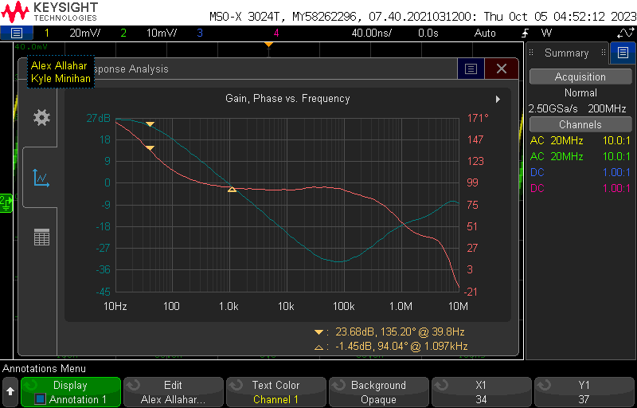

1. **Lossy Integrator Sine Wave Transient Plot**

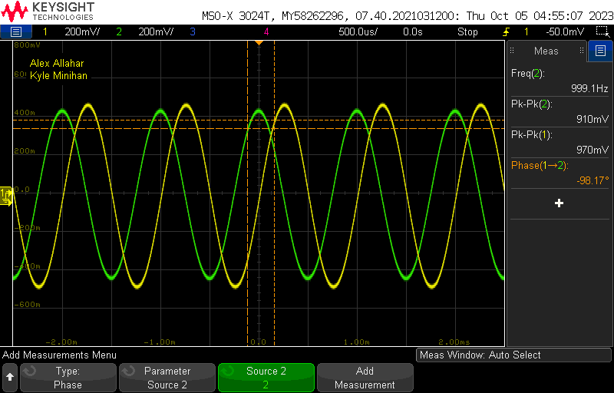

1. **Lossy Integrator Square Wave Transient Plot**

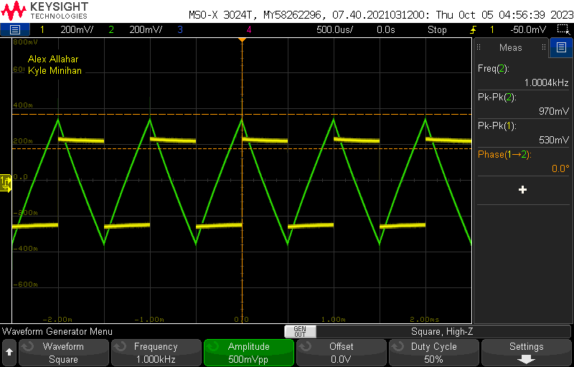

1. **Pseudo Differentiator Bode Plot**

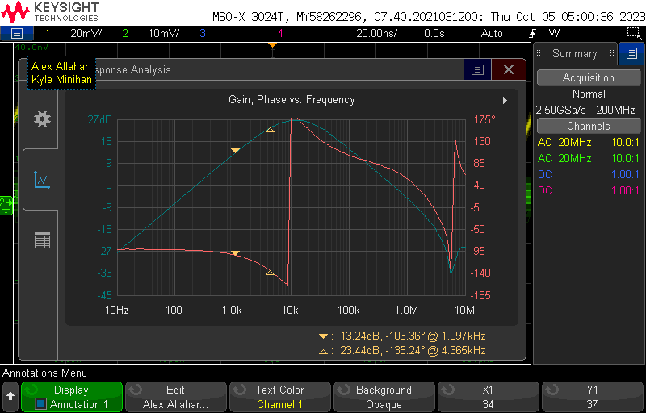

1. **Pseudo Differentiator Sine Wave Transient Plot**

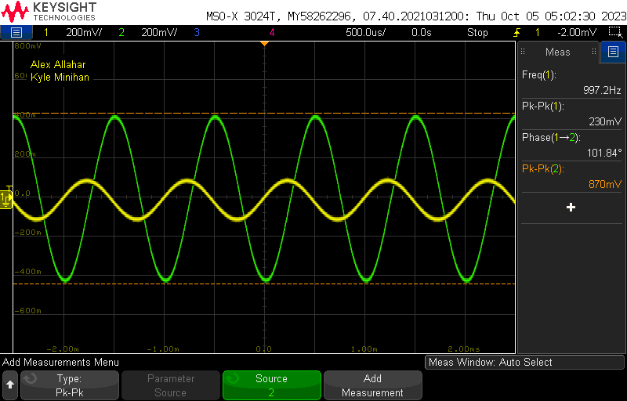

1. **Pseudo Differentiator Triangle Wave Transient Plot**

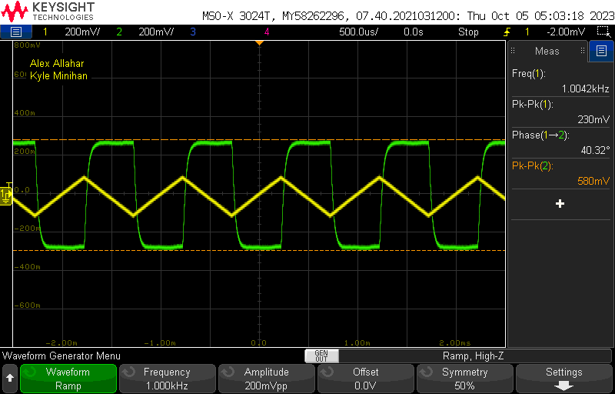

1. **Finite GBW Bode Plot (Gain = 23)**

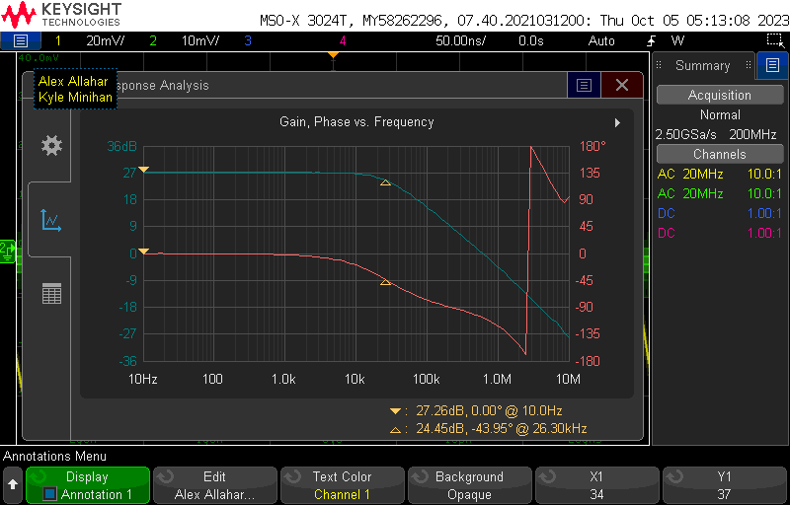

1. **Finite GBW Bode Plot (Gain = 57)**

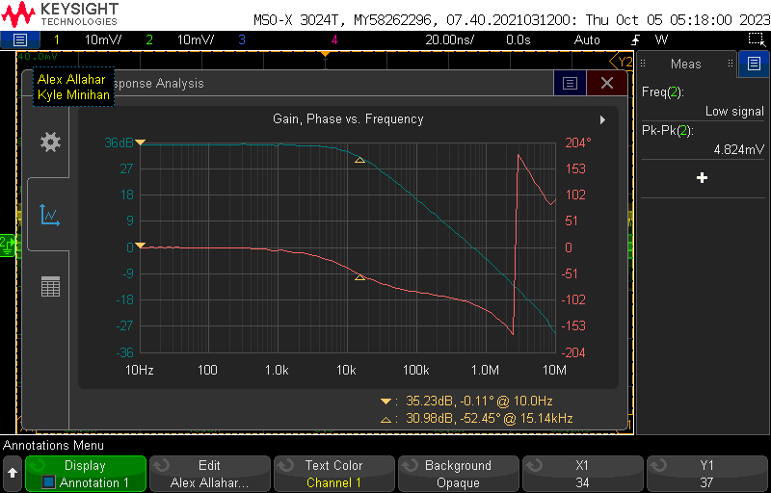

1. **Finite GBW Bode Plot (Gain = 83)**

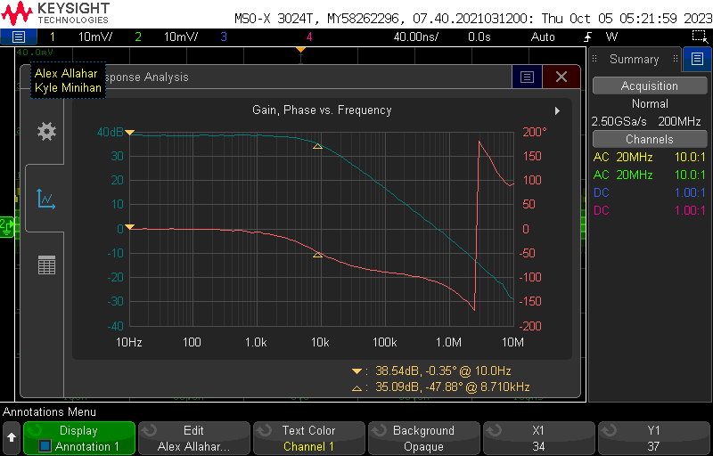

1. **Slew Rate Bode Plot**

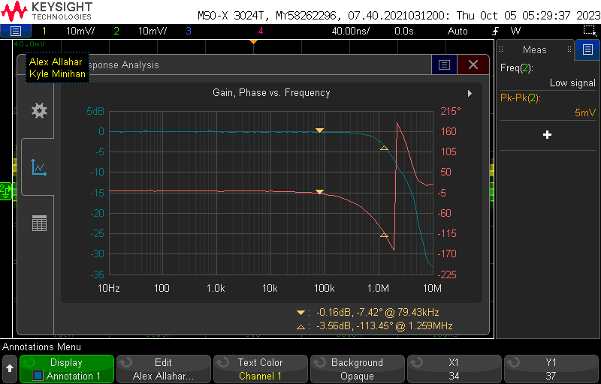

1. **Slew Rate THD Plot (75kHz, 1V)**

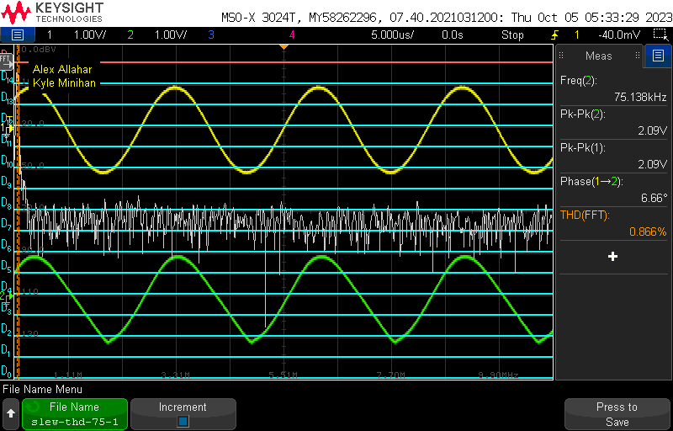

1. **Slew Rate THD Plot (75kHz, 2V)**

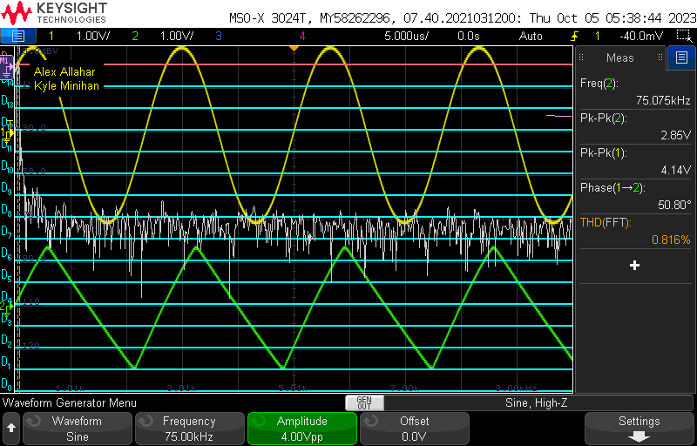

1. **Slew Rate THD Plot (150kHz, 1V)**

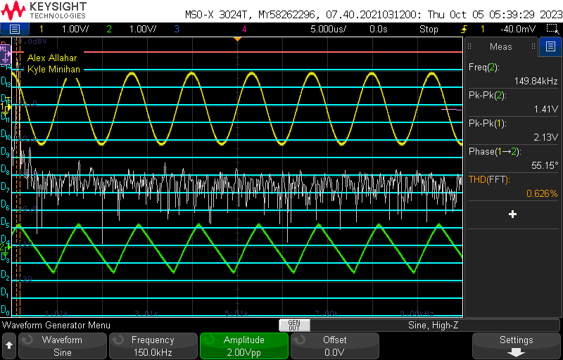

1. **Table**

| Value | Calculated | Simulated | Measured |
| --- | --- | --- | --- |
| Lossy Gain | N/A | 26.843 dB | 27 dB |
| Lossy 3-dB | N/A | 32.257 Hz | 39.8 Hz |
| Lossy Mag (1kHz) | N/A | 0 dB | -1.45 dB |
| Lossy Phase (1kHz) | N/A | 91.883 ° | 94.04 ° |
| Lossy Vin (Sine) | 0.5 V | 1 V | 0.970 V |
| Lossy Vout(Sine) | 0.1 V | 0.786 V | 0.910 V |
| Lossy Vout(Square) | N/A | 0.786 V | 0.530 V |
| Pseudo Gain | N/A | 26.846 dB | 27 dB |
| Psuedo 3-dB | N/A | 4.8939 kHz | 4.365 kHz |
| Pseudo Mag (1kHz) | N/A | 13.00 dB | 13.24 dB |
| Pseudo Phase (1kHz) | N/A | -100 ° | -103.36 ° |
| Pseudo Vin (Sine) | 0.1 V | 0.251 V | 0.230 V |
| Psuedo Vout(Sine) | N/A | 2.2350 V | 0. 870 V |
| Psuedo Vout(Tri) | N/A | 2.2350 V | 0.580 V |
| GBW Gain (23) | R2 = 22 kΩ | 40.1028 dB | 27.26 dB |
| GBW3-dB (23) | N/A | 40.1018 dB | 26.3 kHz |
| GBW Gain (57) | R2 = 56 kΩ | 40.1028 dB | 35.23 dB |
| GBW3-dB (57) | N/A | 40.1018 dB | 15.14 kHz |
| GBW Gain (83) | R2 = 82 kΩ | 40.1028 dB | 38.54 dB |
| GBW3-dB (83) | N/A | 40.1018 dB | 8.710 kHz |
| Slew Gain | N/A | 0 dB | 0 dB |
| Slew 3-dB | N/A | 1.014 MHz | 1.259 MHz |
| Slew Mag (75kHz) | N/A | 0 dB | -0.16 dB |
| Slew Mag (150kHz) | N/A | 0 dB | -0.20 dB |
| THD (75kHz, 1V) | N/A | 1.12403 % | 0.866 % |
| THD (75kHz, 2V) | N/A | 11.7645 % | 0.816 % |
| THD (150kHz, 1V) | N/A | 0.843995 % | 0.626% |

1. **Compare the results and comment on the differences**

When measuring the Lossy Integrator with a Square Wave, we removed R2. Once this was removed the integrator transfer function changed to -1/sR1C. This increased Unity Gain and increased the slope of the dB. Other observations during the lab, were that my simulated result for THD was very off due to the wrong Fourier simulation settings in mutlisim.